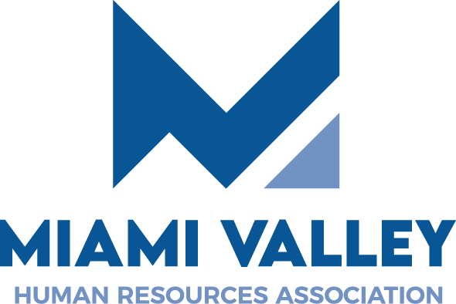

HR Professional Certification SHRM Prep Course or Exam Reimbursement 2025 Fall/Winter
Reimbursement Announcement & Application
Through ongoing commitment to Dayton-area HR professionals and professional development, MVHRA will offer a HR Professional Certification SHRM Prep Course or SHRM Exam Reimbursement for Fall/Winter 2025. The reimbursement is offered as a benefit to MVHRA members only.
Provided you are a MVHRA member in good standing, complete this application and submit it to MVHRA by emailing it to Leigh Oldham, MVHRA HR Certification Committee Chair at certification@mvhra.org to apply for reimbursement. Before submitting this reimbursement application, check your certification exam eligibility through SHRM. This reimbursement is for up to $500 toward prep course fee or reimbursement for having registered, taken and passed SHRM certification. Prep course participants are required to purchase the text used by the SHRM course provider. Course participants will need to meet their certification exam eligibility requirements and also apply for certification prep course participation.
Reimbursement applications must be received no later than December 1, 2025, to be considered. Reimbursement recipient will be selected by members of the MVHRA Board. Reimbursement recipient and applicants will be notified of reimbursement selections no later than December MVHRA Luncheon
Questions can be directed to certification@mvhra.org. Thank you for your interest in a MVHRA HR Professional Certification SHRM Prep Course or Exam Testing reimbursement. Best wishes on your certification journey!

